**Programming Lab 1**

**Talal Jawaid**

**10/11/18**

**CSC 138**

Part 1a – Implementing UDP client/server interaction in Python

UDPClient code

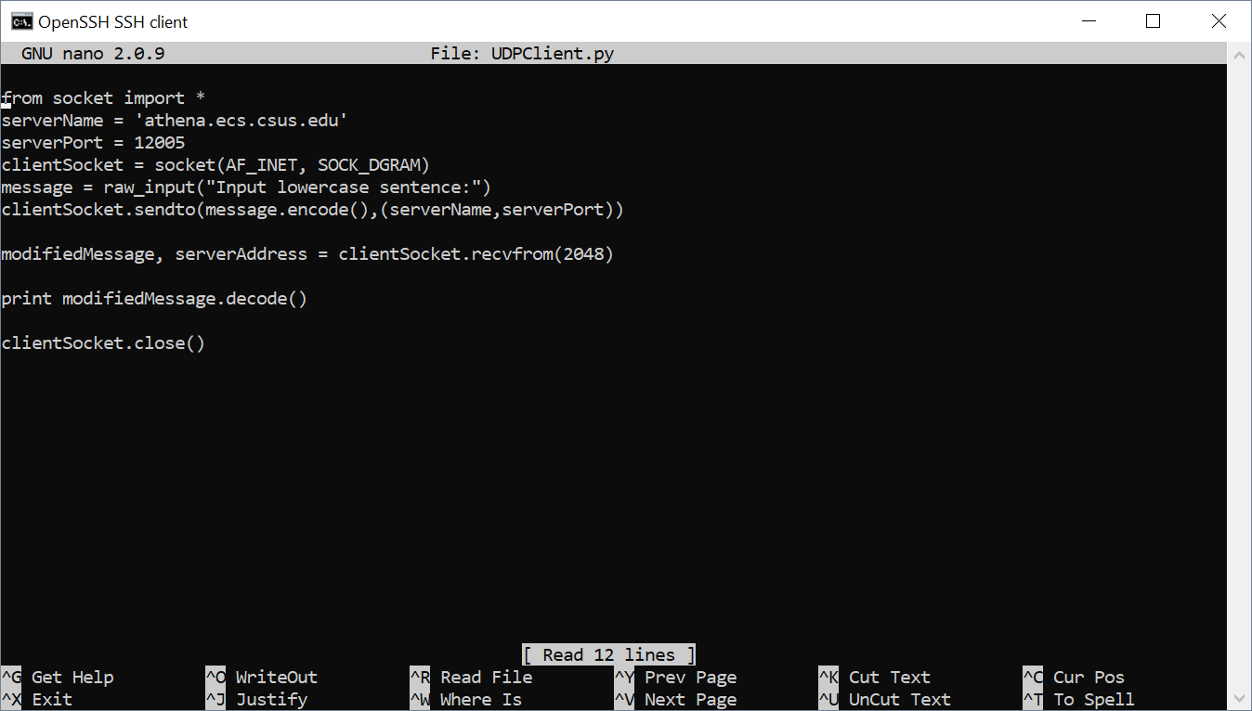

UDP Server Code

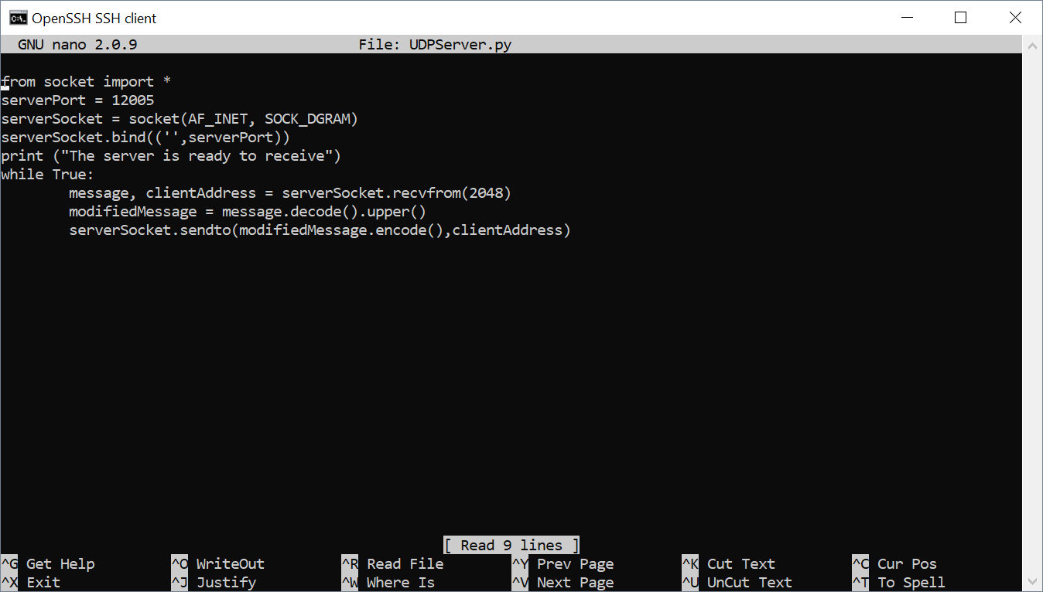

Running UDP Server and Client

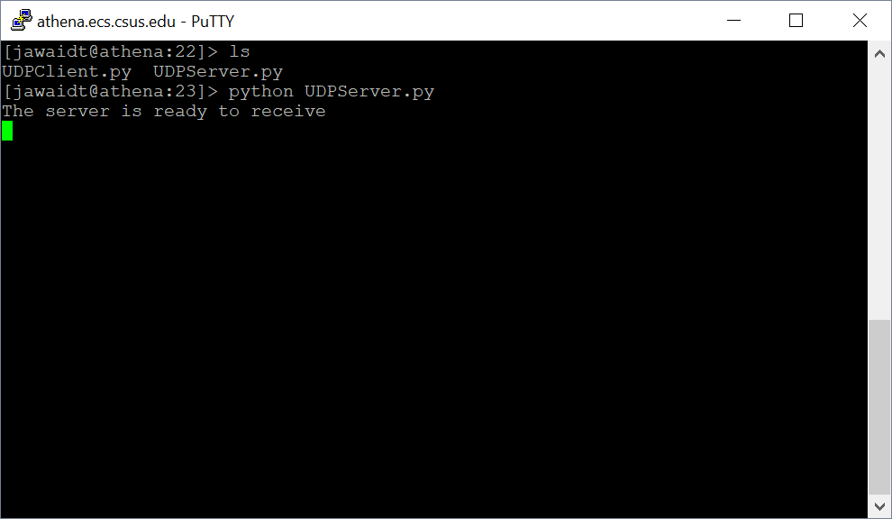

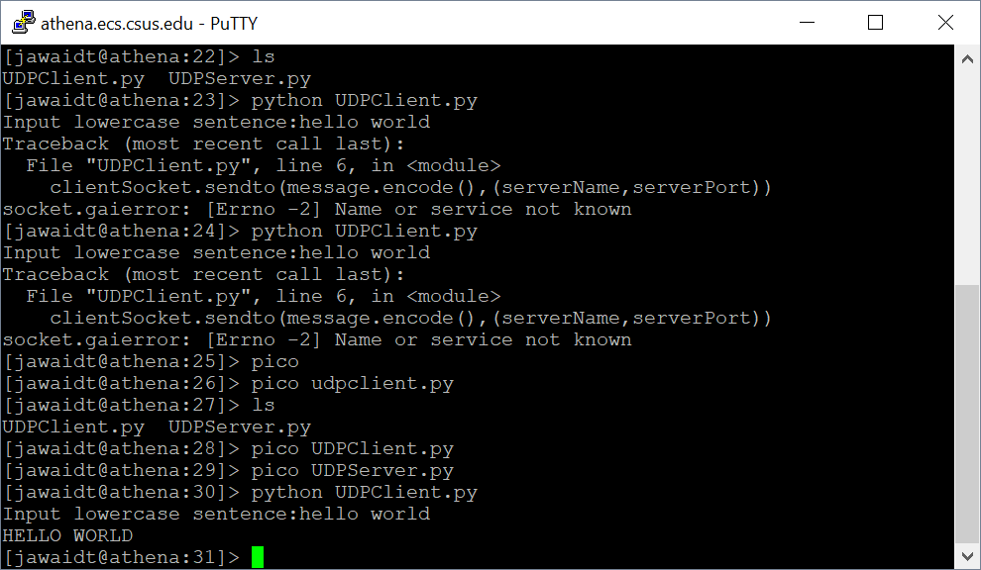

TCP Client/Server Code

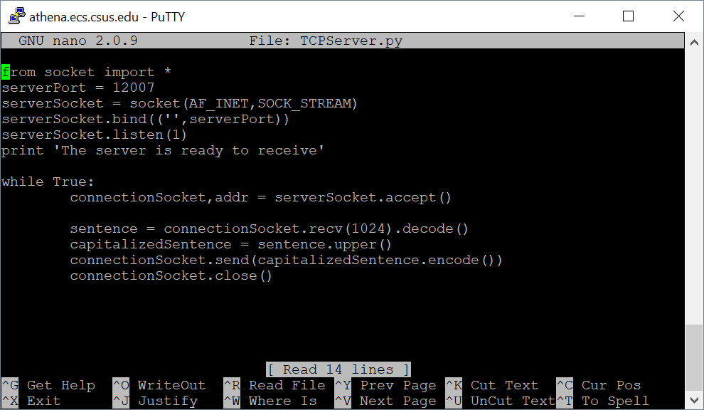

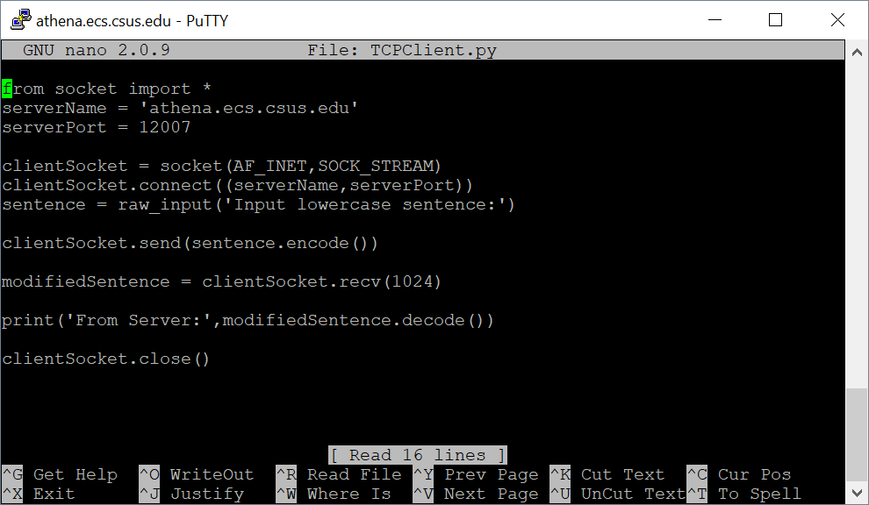

TCP Client/Server running

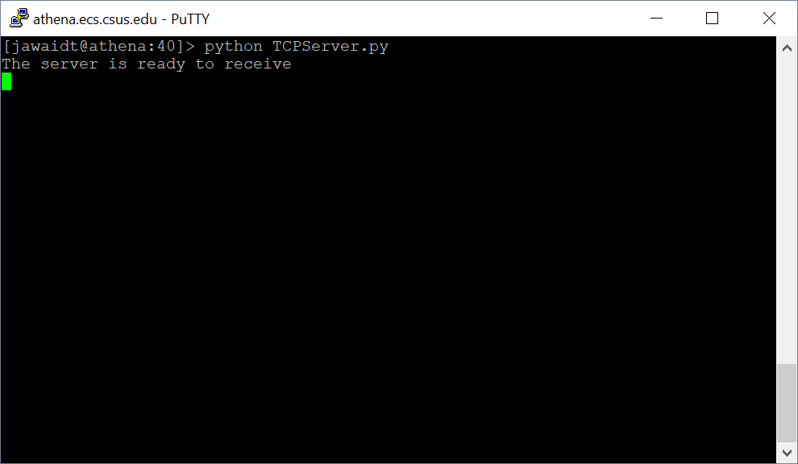

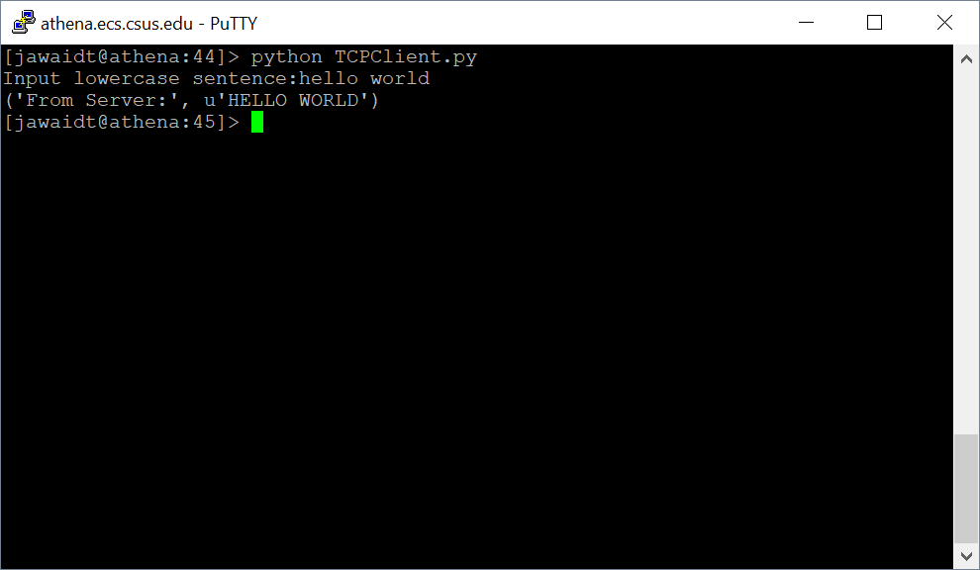

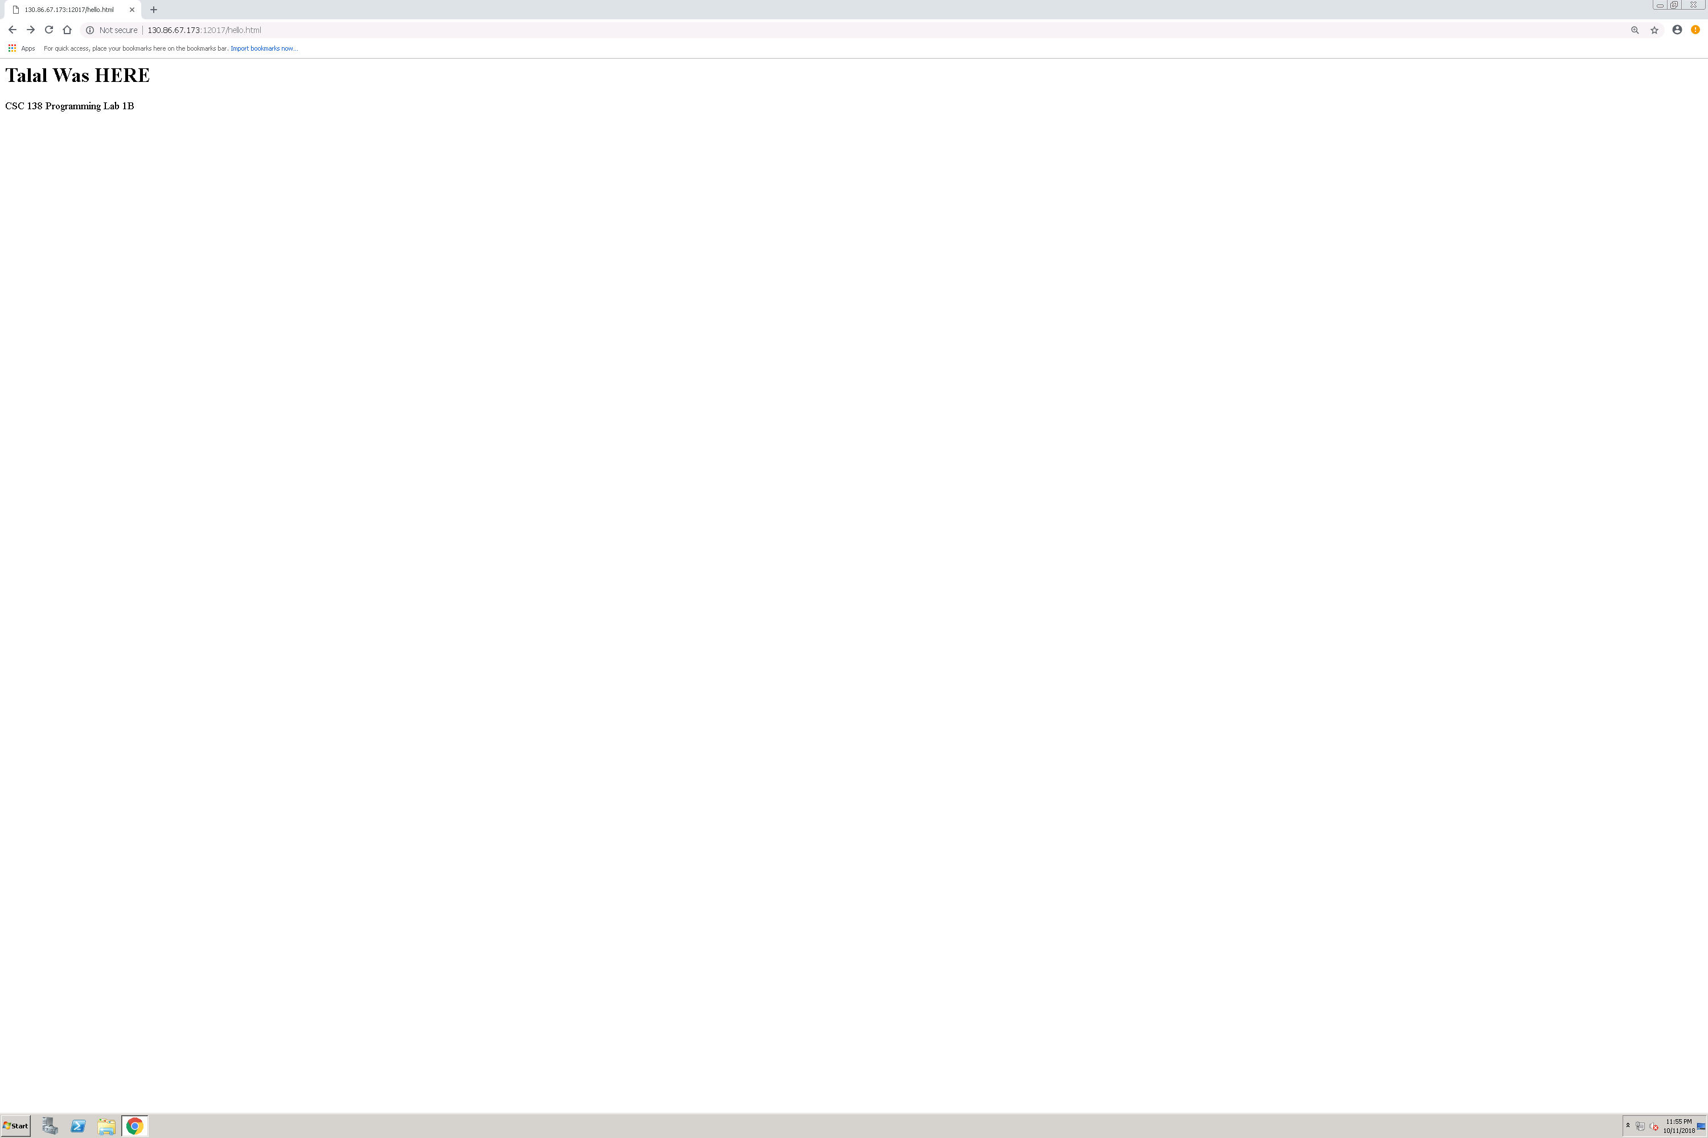

**Part 1C:**

**Code for UDP Pinger Server and Client**

**Server provided by Professor**

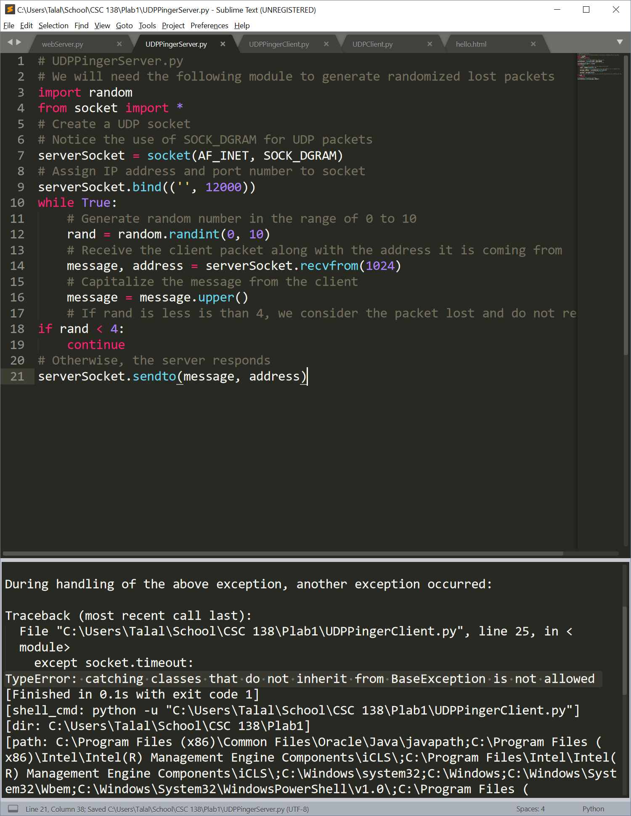

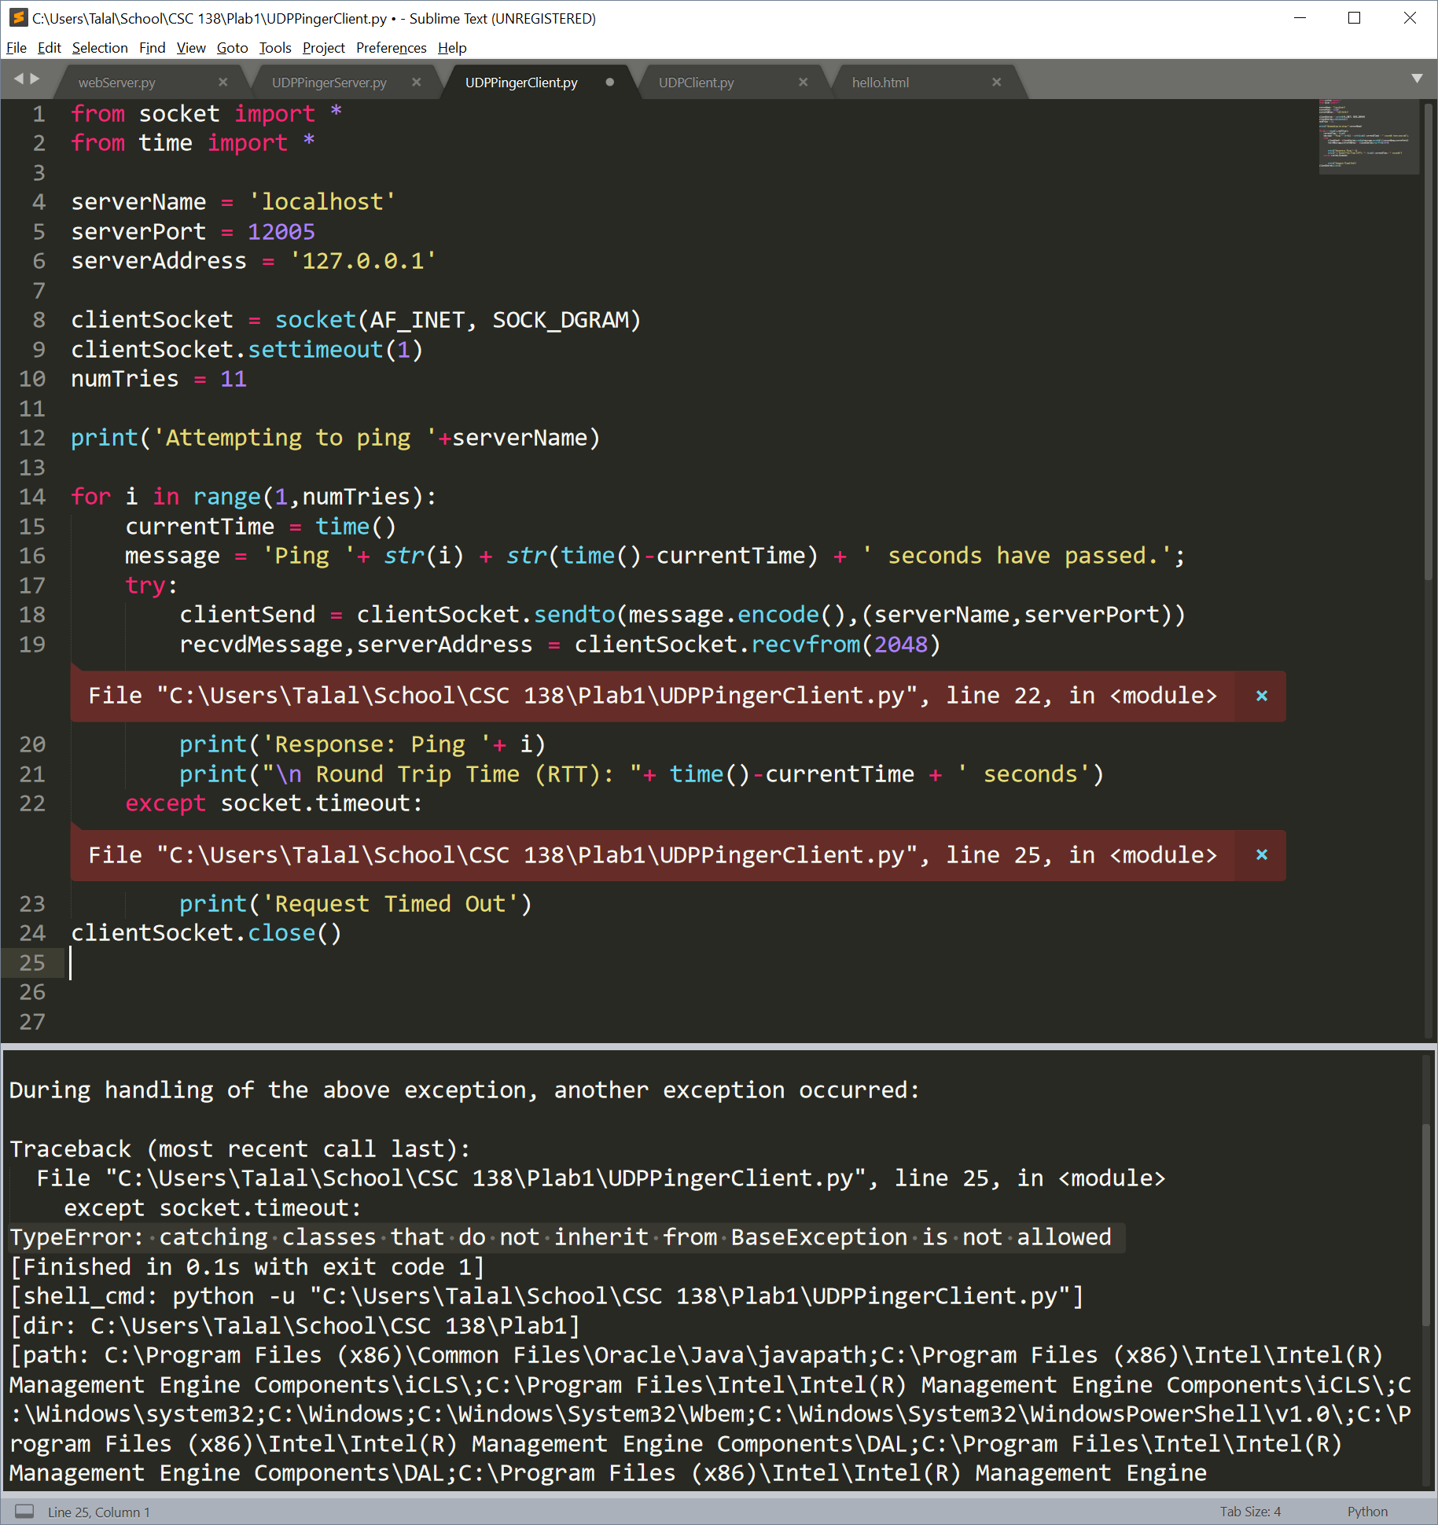

**Attempting to run code**

Couldn’t get Professor’s UDPPingerServer.py to run

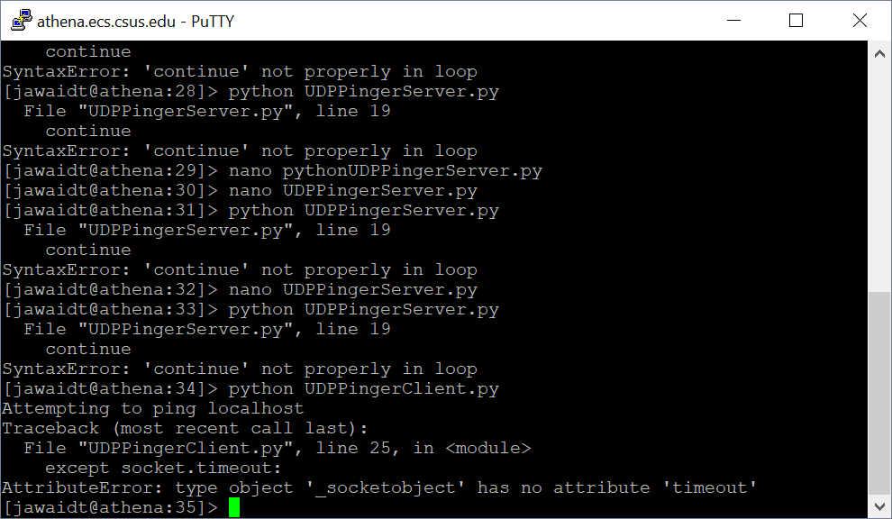

Kept receiving errors on continue not being properly in the loop

Attempting to run UDP Pinger Client

